CLASS 12 PHYSICS
TIME:1 HOUR MAX MARKS:35

(Q1 - Q10) are multiple choice questions.
Q1. A circular coil of radius R carrying current in the clockwise direction is placed in X_Y plane centred at the origin O. The total magnetic flux through X-Y plane due to its Magnetic field B is a) Directly Proportional to R² b) inversly proportional to R² c) zero d) directly proportional to R

Q2. Two circular coils can be arranged in any of the three situations shown in Fig. Their mutual
inductance will be
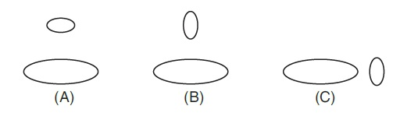

(a) maximum in situation (A)
(b) maximum in situation (B)
(c) maximum in situation (C)
(d) the same in all situations.

Q3. The average emf induced in a coil in which the current changes from 2 ampere to 4 ampere in 0.05 second is 8 volt. What is the self inductance of the coil ?
(a) 0.1 H (b) 0.2 H
(c) 0.4 H (d) 0.8 H.

Q4. A metal ring moves towards a straight wire carrying current. The direction of induced current in the ring is
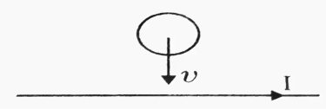
- Clockwise
- Anticlockwise
- Can be Clockwise and Anticlockwise
- zero

Q5. 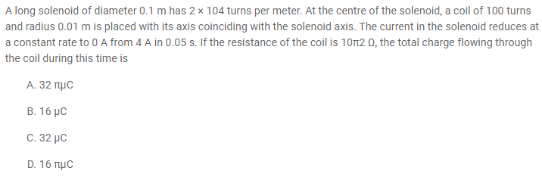

Q6. The magnetic field at the centre of a current carrying circular coil of radius
10cm is 5√5 times the magnetic field at a point on its axis. The distance of the
point from the centre of the circle is
(a) 5cm (b) 10cm (c) 20cm (d) 2cm

Q7. The maximum current that can be measured by a galvanometer of resistance 40
Ω is 10 mA. It is converted into voltmeter that can read up to 50 V. The resistance
to be connected in the series with the galvanometer is
(a) 2010 Ω
(b) 4050 Ω
(c) 5040 Ω
(d) 4960 Ω

Q8. The strength of magnetic field at the centre of circular coil is
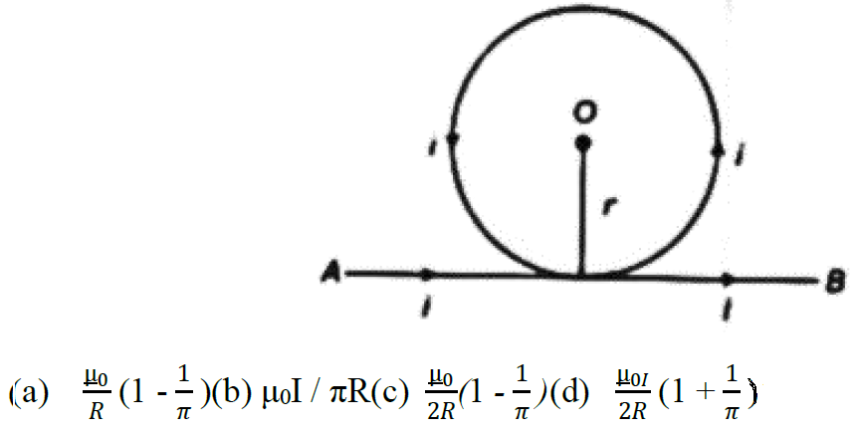

Q9. A coil having 500 square loops of side 10 cm is placed normal to magnetic flux which increases at a rate of 1 T/s. The induced emf is
(a) 0.1 V
(b) 5 V
(c) 1 V
(d) 0.5 V
Q10. Production of Focault’s current in a metal plate by
(a) placing in a constant magnetic field
(b) placing in a time varying magnetic field.
(c) oscillating between the pole pieces of magnet in and out of the magnetic field
(d) both (a) and (b) are correct.

Section :B

For questions 11-19 two statements are given-one labelled Assertion (A) and the other labelled Reason (R). Select the correct answer to these questions from the codes (a), (b), (c),(d) and (e) as given below.
(a) Both A and R are true and R is the correct explanation of A
(b) Both A and R are true but R is NOT the correct explanation of A
(c) A is true but R is false
(d) A is false and R is also false
(e) A is false but R is true

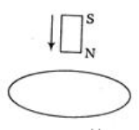
Q11.Assertion : The bar magnet falling vertically along the axis of the horizontal coil will be having acceleration less than g.

Reason : No induced current is produced when there is a cut in the ring .

Q12.Assertion : Production of eddy current is undesirable in dead beat Galvanometer
Reason : A current induced in a coil rotating in a magnetic field produces a force which tends to oppose the coil’s motion .

Q13. Assertion: When the magnetic flux through a loop is maximum, induced emf is maximum.
Reason: Magnetic flux through the coil is maximum when the plane of coil is parallel to the magnetic field B

Q14. Assertion : Eddy current effect is used in Electromagnetic breaking .
Reason : As eddy currents always oppose the relative motion.

Q15. Assertion : A solenoid tends to expand, when a current passes through it.
Reason : Two straight parallel metallic wires carrying current in the same direction repel each other.

Q16. Assertion : An AC generator is based on the phenomenon of self-induction.
Reason – Split rings are used in Ac generator to get AC output.

Q17. Assertion : Generally Coil in the resistance boxes are made by doubling the wire.
Reason : No of turns of the coil is doubled , the Self induction effect will also be doubled.

Q18. Assertion : The torque acting on square and circular current carrying coils having equal areas, placed in uniform magnetic field, will be same.
Reason (R):Torque acting on a current carrying coil placed in uniform magnetic field B is same for Square coil and a irregular shaped coil having same area .

Q19. Assertion : A phosphor bronze strip is used in a moving coil galvanometer.
Reason : Phosphor bronze strip has the maximum value of torsional constant k.

SECTION C:

Q 20 -23 are case study based questions and are compulsory. Each question carries 4 marks.
Q20

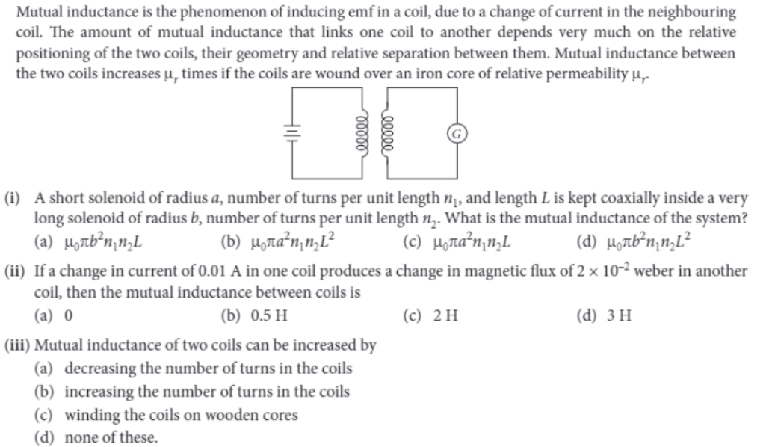
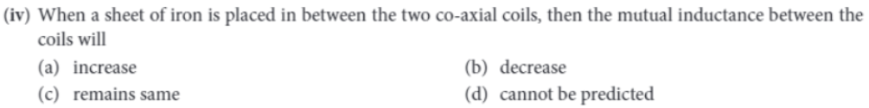

Q21.
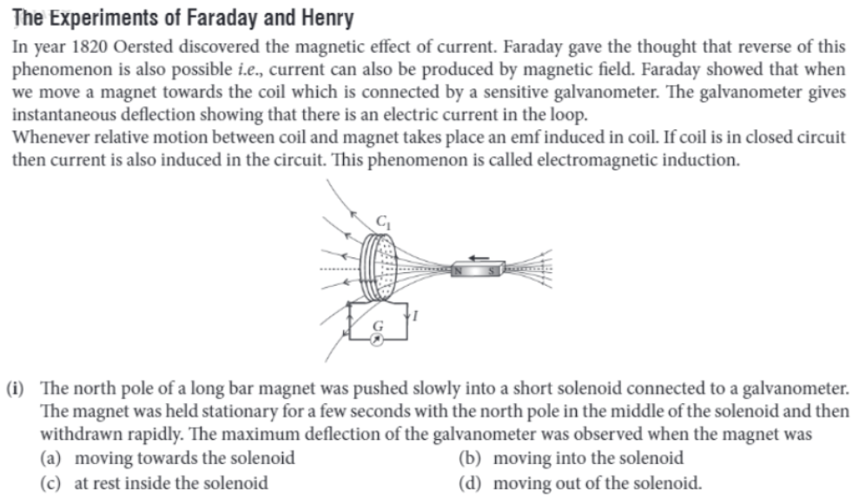

Q22. Bubble Chamber: Trails of bubbles are produced by high-energy charged particles moving through the superheated liquid hydrogen in this artist’s rendition of a bubble chamber. There is a strong magnetic field perpendicular to the page that causes the curved paths of the particles. The radius of the path can be used to find the mass, charge, and energy of the particle.
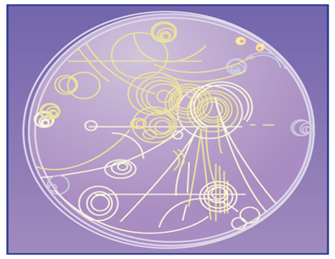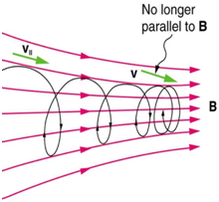

Magnetic forces can cause charged particles to move in circular or spiral paths. Particle accelerators keep protons following circular paths with magnetic force. Cosmic rays will follow spiral paths when encountering the magnetic field of astrophysical objects or planets (one example being Earth’s magnetic field). The bubble chamber photograph in the figure below shows charged particles moving in such curved paths. The curved paths of charged particles in magnetic fields are the basis of a number of phenomena and can even be used analytically, such as in a mass spectrometer. shows the path traced by particles in a bubble chamber.
1. When a charged particle moves perpendicular to a uniform electric field, it follows-
(a) circular path (b) parabolic path
(c) translational path (d) helical path
2. A charged particle moving with velocity v in X direction is subjected to a magnetic field B in negative X direction. As a result, the charge will
(a) retard along X-axis
(b) start moving in a circular path in YZ plane
(c) remains unaffected
(d) move in a helical path around X-axis
3. An α- particle and proton having same momentum enter into a region of uniform magnetic field and move in a circular path. The ratio of the radii of curvature of their paths
(a) 1 (b) ¼ (c) ½ (d) 4
4. A neutron, a proton, an electron and an α- particle enter in a region of uniform magnetic field with equal velocities. The magnetic field is perpendicular and directed into the paper. The tracks
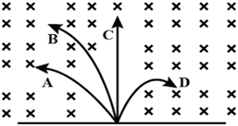

of the particles are shown in figure. The electron will follow the track-
(a) A (b) B (c) C (d) D

Q23. 